LOYOLA JESUIT SECONDARY SCHOOL
2026 MALAWI SCHOOL CERTIFICATE OF EDUCATION MOCK EXAMINATIONS

PHYSICS
Subject Number: M162/II
____/______/2026 Time Allowed: 2 hour sessions
10 am onwards

PAPER II
(40 marks)
PRACTICAL
Instructions
Question  Number | Tick if answered | Do not write in these columns
1

2

3

4

- This paper contains 7 printed pages. Please check.
- Write your Name at the top of each page.
- Answer all the four questions in the spaces provided.
- The maximum number of marks for each answer is indicated against each question.
- In the table provided on this page, tick against the question number you have answered.

Turn over
Section A (20 marks)
Answer all questions in this section
- With the aid of well-labeled diagrams, describe an experiment that could be carried out to demonstrate how viscosity of two different fluids affects the speed of an object falling through it.

___________________________________________________________________________________________________________________________________________________________________________________________________________________________________________________________________________________________________________________________________________________________________________________________________________________________________________________________________________________________________________________________________________________________________________________________________________________________________________________________________________________________________________________________________________________________________________________________________________________________________________________________________________________________________________________________________________________________________________________________________________________________________________________________________________________________________________________________________________________________________________________________________________________________________________________________________________________________________________________________________________________________________________________________ ___________(10 marks)
- With the aid of well labeled diagram, describe an experiment that can be done to determine the centre of gravity of thin lamina using a plumb-line.

_______________________________________________________________________________________________________________________________________________________________________________________________________________________________________________________________________________________________________________________________________________________________________________________________________________________________________________________________________________________________________________________________________________________________________________________________________________________________________________________________________________________________________________________________________________________________________________________________________________________________________________________________________________________________________________________________________________________________________________________________________________________________________________________________________________________________________________________________________________________________________________________________________________________________________________________________________________________________________________________________________________________________________________________________________________________________________(10 marks)
Section B (20 marks)
Answer all questions in this section
- You are provided with a candle, matches, a lens holder, convex lens, a white screen and a meter rule.
    - Arrange the candle , convex lens and screen as shown Figure 1 below:
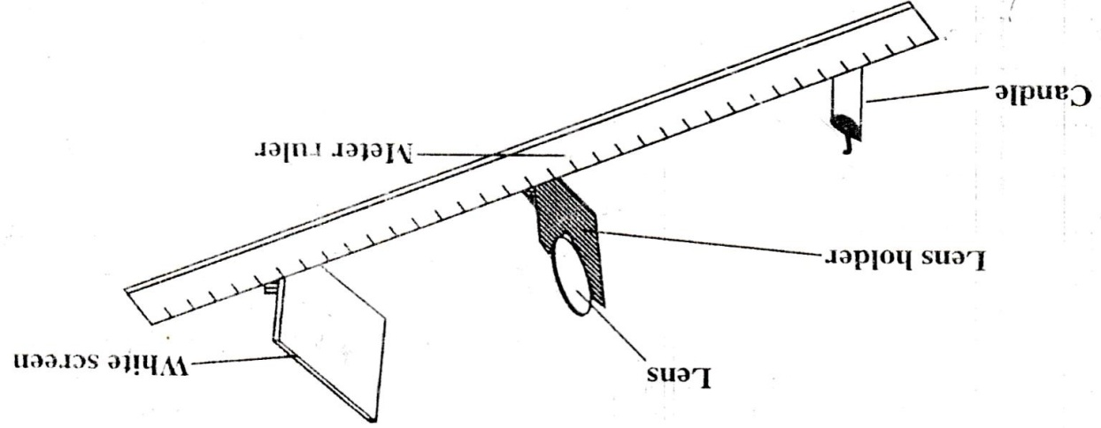
Figure 1
    - Light the candle.
    - With the candle at 20 cm from the lens, produce a clear image of the flame on the white screen.
    - Measure and record the image distance in the table of results.
    - Repeat steps (c) and (d) for the object distances shown in table 1 below:
Table of results
Object distance(u)  (cm) | Image distance (v)  (cm) | u + v  (cm)
20
25
30
35
40
Table 1
(5 marks)

    - Calculate (u + v) for each set of object and image distances and record in table 1 above.
    - Plot a graph of ( u + v) against u.
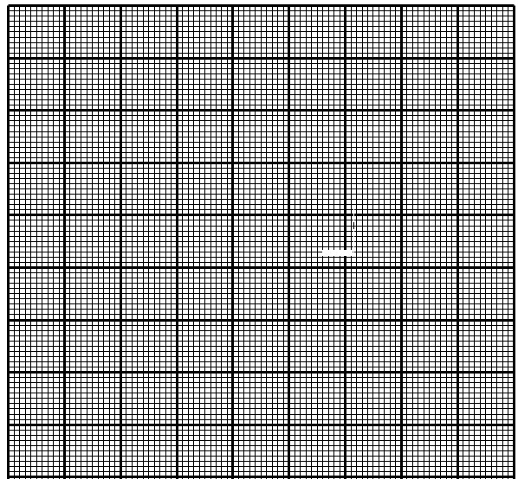
(4 marks)
    - Using the graph, find the focal length of the lens.

(2 marks)
- You are provided with the following materials: An ammeter, a voltmeter, connecting wires, 2 dry cells, 2 resistors and a switch.
- Connect the circuit as shown in figure 2 a.
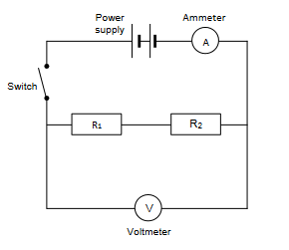

Figure 2.a
- Close the switch and record ammeter and voltmeter readings in Table 2 a.
Ammeter reading  (A) | Voltmeter reading  (V)
Table 2a.
(2 marks)
- Calculate resistance in the arrangement shown in figure 2.a.

(2 marks)

- Connect the circuit as shown in Figure 2.b below.
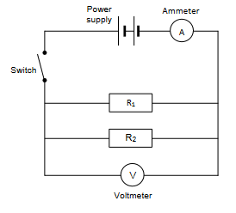
Figure 2.b

- Close the switch and record ammeter and voltmeter readings in Table 2b.
Ammeter reading (A) | Voltmeter reading (V)
Table 2b
(2 marks)
- Calculate resistance in the arrangement shown in figure 2.b.

(2 marks)

- Compare the resistances in the arrangement of bulbs in part 1d and that of part 1h.
___________________________________________________________________________________________________________________________________________________(1 mark)
- Draw an appropriate conclusion in this experiment.
___________________________________________________________________________________________________________________________________________________(1 mark)
END OF QUESTION PAPER

